H.T No
Regulations:
A20

Sreenidhi Institute of Science and Technology
(An Autonomous Institution)
Code No:8B736 Date: 04-01-2025 (FN)

B.Tech IV-Year I-Semester External Examination, January-2025 (Supplementary)
Industrial Management (Mechanical)

Time: 3 Hours Max.Marks:70

Note: a) No additional answer sheets will be provided.
b) All sub-parts of a question must be answered at one place only, otherwise it will not be valued.
c) Missing data can be assumed suitably.

Bloom's Cognitive Levels of Learning (BCLL)

Remember | L1 | Apply | L3 | Evaluate | L5
Understand | L2 | Analyze | L4 | Create | L6

Part - A Max.Marks:20
Answer all QUESTIONS

 |  | BCLL | CO(s) | Marks
1 | Define entrepreneurship | L1 | CO1 | [2M]
2 | What do you mean by Virtual organization? | L2 | CO2 | [2M]
3 | Write short notes on FAST diagram | L1 | CO3 | [2M]
4 | Distinguish between method study and time study | L2 | CO4 | [2M]
5 | State the benefits of job evaluation | L1 | CO5 | [2M]
6 | Define free float | L1 | CO6 | [2M]
7 | State the social responsibilities of management | L2 | CO1 | [2M]
8 | Enlist the symbols and its description of flow process charts | L2 | CO4 | [2M]
9 | Differentiate PERT and CPM | L2 | CO6 | [2M]
10 | What do you understand by committee organization structure. | L2 | CO2 | [2M]
Part – B Max.Marks:50
ANSWER ANY FIVE QUESTIONS. EACH QUESTION CARRIES 10 MARKS.

 |  |  | BCLL | CO(s) | Marks
11. | a) | List out Fayol’s principles of management. Explain any four principles which you consider as very significant. | L2 | CO1 | [5M]
 | b) | Explain systems approach of management | L2 | CO1 | [5M]
12. | a) | What are the methods of departmentation? Describe them briefly. | L2 | CO2 | [5M]
 | b) | Discuss briefly the salient features of matrix organization structure. | L2 | CO2 | [5M]
13. |  | Consider the assembly network shown in fig. Which shows precedence relationship and duration for each operation (minutes) in assembling project. The required production volume in 8-hours shift is 24 assembly. Design the assembly line using RPW algorithm.  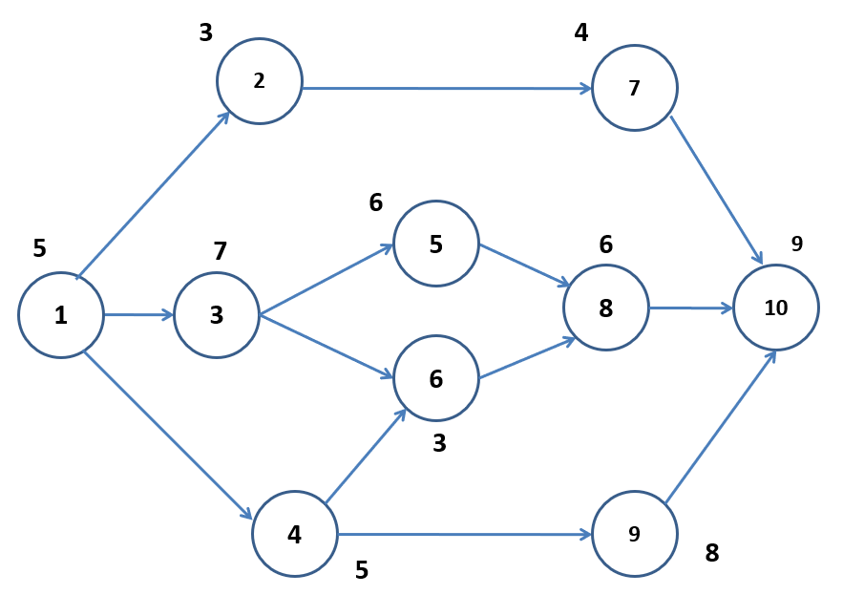 | L3 | CO3 | [10M]
14. | a) | A job is sub- divided into three elements. The time for each element and respective rating are given below:  Determine the normal time and standard time for the job if the allowance is 10%. | L3 | CO4 | [5M]
  Element Number | Observed Time (Minutes) | Rating Factor %
  1 | 8.4 | 120
  2 | 25.2 | 125
  3 | 26.4 | 95
 | b) | Construct X bar and R-charts from the following information and state whether the process is in control. Given A₂ = 1.02 and D₃ = 0.00 and D₄ = 2.57 | L3 | CO4 | [5M]
   | 1 | 2 | 3 | 4 | 5
  Mean X | 0.494 | 0.496 | 0.50 | 0.505 | 0.499
  Range R | 0.017 | 0.005 | 0.028 | 0.022 | 0.018
15. |  | Describe the ranking method and classification method of job evaluation in detail. | L2 | CO5 | [10M]
16. |  | The following is a table showing details of a project:  Indirect cost is Rs. 70 per day.  (i) Draw the network of the project  (ii) What is the normal duration cost of the project?  (iii) What will be the minimum Project duration and corresponding cost? | L3 | CO6 | [10M]
  Activity | Normal |  | Crash
  Activity | Time(days) | Cost(Rs) | Time(days) | Cost(Rs)
  1-2 | 8 | 100 | 6 | 200
  1-3 | 4 | 150 | 2 | 350
  2-4 | 2 | 50 | 1 | 90
  2-5 | 10 | 800 | 5 | 400
  3-4 | 5 | 100 | 1 | 200
  4-5 | 3 | 80 | 1 | 100
17. |  | Discuss the salient features of Herzberg’s Two-Factor Theory of Motivation | L2 | CO1 | [10M]
18. |  | Explain the working principle of double sampling plan with help of a flow chart | L2 | CO4 | [10M]
-- 00 -- 00 –

